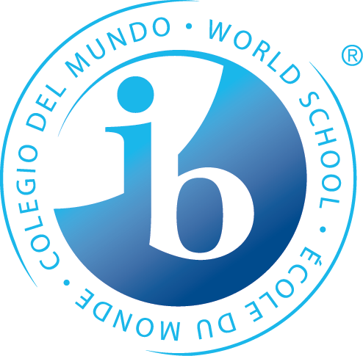
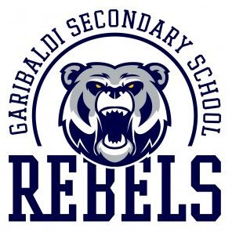
Garibaldi Secondary School
International Baccalaureate Diploma Programme
2024 – 2025 APPLICATION PACKAGE

This package has been developed to assist us in placing students in the SD42 IB Diploma Programme at Garibaldi Secondary School. Our hope is to be able to place all interested students. However, we cannot guarantee that all students who are interested in the program will be accepted. Questions may be directed to our IB DP Coordinator, Mr. Kyle Ludeman, at kyle_ludeman@sd42.ca, or Principal Ian Liversidge at ian_liversidge@sd42.ca .

Please type or print legibly.

APPLICANT INFORMATION

Student name
SD42 student number
Student email
Parent email(s)
Address
Phone number(s)
Current school
Do you have an IEP?

LANGUAGES

Fluent
Please list the language(s) in which you are a fluent reader, writer, speaker, and thinker.
Learning (Language acquisition)
Please list all language acquisition courses that you have taken in grades 9 and 10.

TEACHER REFERENCES

References
Please name one or two teachers who could provide us with a detailed description about what kind of learner you are.

EXTRA-CURRICULAR ACTIVITIES

Extra-curricular
Please list your current extra-curricular activities. Include both school and community-based activities.

COURSE SELECTION

The following IB DP subjects - plus the DP Core - are offered at Garibaldi, organized into six subject groupings.

Group 1 - Studies in Language & Literature  •English A Literature HL | Group 2 - Language Acquisition  •French B SL  •French Ab initio  •Language A Literature – SSST SL | Group 3 - Individuals & Societies  •History SL or HL  •Economics SL or HL  •Philosophy SL or HL
Group 4 – Sciences  •Chemistry SL  •Biology SL or HL  •Computer Science SL or HL | Group 5 – Mathematics  •Mathematics: Analysis & Approaches SL | Group 6 - The Arts  •Visual Arts SL or HL  •Music SL

The anticipated Grade 11 IB DP timetable is shown below. When choosing your courses please note that you cannot choose two courses that are offered in the same block.

Block | Grade 11 IB DP Course (Group)
A | - English A Literature HL (Group 1)
B | - French B SL (Group 2)
C | - Chemistry SL (Group 4)
D | - History HL (Group 3)
E | - Mathematics: Analysis and Approaches SL (Group 5)
F | - Biology SL or HL (Group 4)  - Computer Science SL or HL (Group 4)
G | - Economics SL or HL (Group 3)  - Philosophy SL or HL (Group 3)  - Visual Arts SL or HL (Group 6)  - Music SL or HL (Group 6)
H | - IB Diploma Core (TOK, EE, CAS)
Outside  Timetable | - Language A Literature – SSST (School Supported Self Taught) SL (Group 2)  - French Ab initio (Group 2)  - Optional online fee-based Pamoja courses (see GSS IB DP website for explanation)

Full IB Diploma Option

If you wish to complete the full Diploma, select your IB Diploma courses based on the criteria listed here:
- Choose one course from each of Groups 1 to 5 (You cannot take two courses offered in the same Block).
- Choose a sixth course, either a Group 6 course or another Group 1, 2, 3 or 4 course.
- Ensure that you have three HL (Higher Level) courses and three SL (Standard Level) courses.
- The DP Core (Theory of Knowledge - Extended Essay - Creativity, Activity, Service) is required.

Note that:
- Courses are a two-year commitment (grades 11 and 12).
- You are responsible for organizing specific university entrance requirements that may need to be met outside of your Diploma choices (e.g., Physics 11 is required for some science programs).

Subject Group | Course | Level
Group 1 | English A Literature | HL
Group 2
Group 3
Group 4
Group 5 | Mathematics: Analysis and Approaches | SL
Sixth course
DP Core | DP Core (TOK, EE, CAS) | ---

Individual Course(s) Option

If you wish to complete individual IB DP courses:
- Select one or more IB Diploma courses. (You cannot take two courses offered in the same Block).

Note that:
- Courses are a two-year commitment (grades 11 and 12).
- You are responsible for ensuring that all graduation requirements are met between IB DP and regular program courses.
- Students must commit to attend additional HL hours as scheduled.
- Full Diploma students will be placed in courses first. If there is space, individual course students will then be placed.

Individual Courses | Course | Level
Course 1
Course 2
Course 3
Course 4
Course 5

Final Course Selection

Final course selection will be determined as part of the IB intake interview that will be scheduled when this application is received.

IB DP FEES

Full IB Diploma Fees
The cost for the full IB Diploma is $600 per year for a total of $1,200.
- $600.00 payable in November of the first year.
- $600.00 payable in November of the second year.

Individual Course Fees
The cost for individual IB DP courses is $120 per course, with a cap of $500, payable in November of the second year.

APPLICATION PACKAGES

All applications are due by the first Friday in March.

GSS students
- Please deliver application packages directly to Mr. Liversidge.
Non-GSS students
- Please email application packages to ian_liversidge@sd42.ca .
- Attach a copy of your first term report card with your application.
- A confirmation email indicating receipt of your application package will be sent to you.
- Please contact Mr. Liversidge directly if you do not receive this confirmation email.

PARENT SIGNATURE

I support my child’s application to the IB Programme at Garibaldi Secondary School. I acknowledge the IB DP fees and the due dates for those fees.

Signature of Parent / Guardian Date

